**CAP4630 Introduction to Artificial Intelligence**

**Homework 4 (9 pts, Due Oct 20 2022)**

[Homework solutions must be submitted through Canvas. No email submission is accepted. Only pdf, word, and txt files are allowed. If you have multiple pictures, please include all pictures in one Word/pdf file. You can always update your submissions before due date, but only the latest version will be graded.]

1. **[1 pt]** Given two admissible heuristics  and , which of the following heuristic are admissible or may be admissible (explain why)
   1. 

Assuming that each heuristic has the same optimal number of moves, and since h1(n) and h2(n) are both admissible heuristics, then no matter which one is chosen as max, it must be an admissible heuristic. If the optimal number of moves were different for each heuristic, than it would be “may be admissible”. But since I’m making the assumption that the heuristics have the same optimal number of moves, than the answer is admissible.

* 1. 

Assuming that each heuristic has the same optimal number of moves, and since h1(n) and h2(n) are both admissible heuristics, then no matter which one is chosen as min, it must be an admissible heuristic. If the optimal number of moves were different for each heuristic, than it would be “may be admissible”. But since I’m making the assumption that the heuristics have the same optimal number of moves, than the answer is admissible.

* 1. *h*(*n*)*=*max{*h1*(*n*)*, h2*(*n*)} *–* min{*h1*(*n*)*, h2*(*n*)

Assuming that each heuristic has the same optimal number of moves, and since h1(n) and h2(n) are both admissible heuristics, then subtracting the min from the max will always result in an admissible heuristic. If both numbers were the same, it would still be equal to 0. If the optimal number of moves were different for each heuristic, than it would be “may be admissible”. But since I’m making the assumption that the heuristics have the same optimal number of moves, than the answer is admissible.

* 1. 

Assuming that each heuristic has the same optimal number of moves, and since h1(n) and h2(n) are both admissible heuristics, then adding both would make it inadmissible, but dividing it by two brings it back to being heuristic. i.e. if the optimal cost was 25 for h1(n) and h2(n), adding both would be 50, but dividing by 2 makes it the optimal cost of 25 again. This will always result in an admissible heuristic. If the optimal number of moves were different for each heuristic, than it would be “may be admissible”. But since I’m making the assumption that the heuristics have the same optimal number of moves, than the answer is admissible.

* 1. , where 

Assuming that each heuristic has the same optimal number of moves, and since h1(n) and h2(n) are both admissible heuristics, and the multiplying factor of w will always be 0 <= w <= 1, it will stay within admissible bounds. I have given examples below. If the optimal number of moves were different for each heuristic, than it would be “may be admissible”. But since I’m making the assumption that the heuristics have the same optimal number of moves, than the answer is admissible.

Optimal Cost = 20

h(n) = 1 * h1(n) + 0 * h2(n) = h1(n)

h(n) = 0 * h1(n) + 1 * h2(n) = h2(n)

h(n) = 0.9 * 15 + 0.1 * 17 = 13.5 + 1.7 = 15.2

h(n) = 0.9 * 20 + 0.1 * 20 = 18 + 2 = 20

1. **[1 pt].** Figure 1 lists the initial state and the goal state of Eight Puzzle game (with eight numbered-tiles and one empty tile, *i.e.*, the white tile). A state N is given as an initial state, and the Goal state is also listed in the figure.
2. Please use three heuristics (1) number of misplaced numbered-tiles, (2) Manhattan distance, (3) sum of permutation inversions, to calculate heuristic scores between N and the goal state, respectively. [0.75]

h1(n) = 2

h2(n) = 2

h3(n) = 4

1. Explain whether each of the three heuristics is an admissible heuristic or not (explain why). [0.25]

h1(n) = Yes it is admissible because it is over zero and <= to optimal cost.

h2(n) = Yes it is admissible because it is over zero and <= to optimal cost.

h3(n) = No it is not admissible because it exceeds the optimal cost.

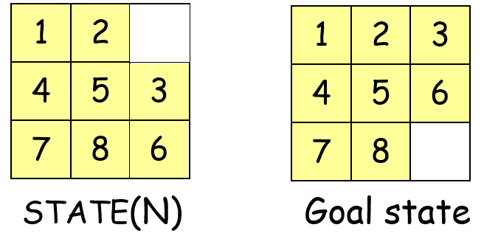

Figure 1: Eight puzzle game. An initial state N (left), and the goal state (right)

1. **[1 pt]**. Figure 2 lists the initial state and the goal state of Eight Puzzle game (with eight letter-tiles and one empty tile, *i.e.*, the white tile). Please use Best-First Search to build a search tree to carry out search from the initial state to the goal state.
   1. Use Manhattan distance between each letter-tile and its goal position as the heuristic function, and report the search tree from the initial node to the goal node (please also include the evaluation function values F(N) and heuristic function values h(N) for each note).

See work on paper.

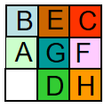 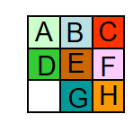

1. Initial State (b) Goal State

Figure 2: Eight Puzzle Game

1. **[1 pt]**. Figure 2 lists the initial state and the goal state of Eight Puzzle game (with eight letter-tiles and one empty tile, *i.e.*, the white tile). Please use A* search to build a search tree to carry out search from the initial state to the goal state.
2. Please use Manhattan distance between each letter-tile and its goal position as the heuristic function, and report the search tree from the initial nodes to the goal node (please include the evaluation function values f(N), g(N), and h(N) for each node).

See work on paper

1. **[1 pt]** Figure 3 shows a simplified map of part of Romania, and Table 1 reports the straight-line distance from each city to Bucharest. Please trace the operation of A* search applied to the problem of getting to Bucharest from Oradea using the straight-line distance heuristic. Show the sequence of expanded nodes and the g(N), h(N), and f(N) scores for each node.

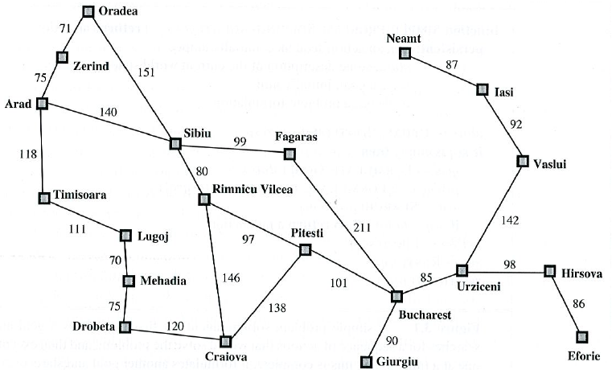

Figure 3: Romania map

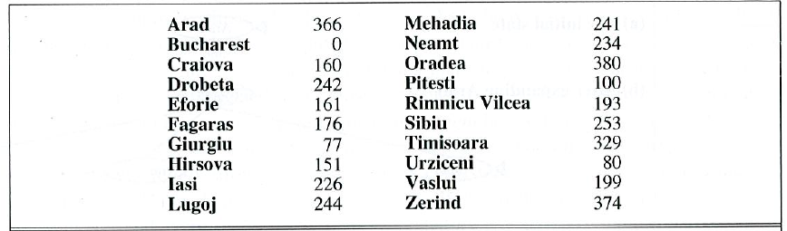

Table 1: straight-line distance from each city to Bucharest.

1. **[1 pt]** Figure 4 shows a robot navigation field, where the red square (d2) is the robot, and green square (c7) is the goal. The shad squares (such as b2, c2, etc.) are obstacles. The robot is not allowed to move in diagonal line. Please use best first search to find the path from d2 to c7

* Report nodes in the fringe (including their f(N) values), in the orders they are included in the fringe. [0.5]
* Report the order of the nodes being expanded. [0.25]

19

* Report the final path from d2 to c7. [0.25]

** See attachments **

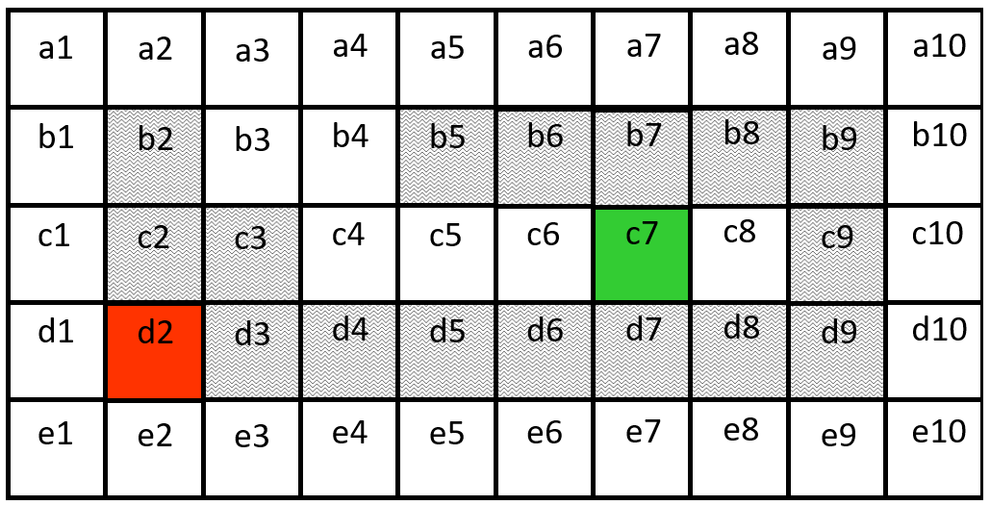

Figure 4 Robot navigation field.

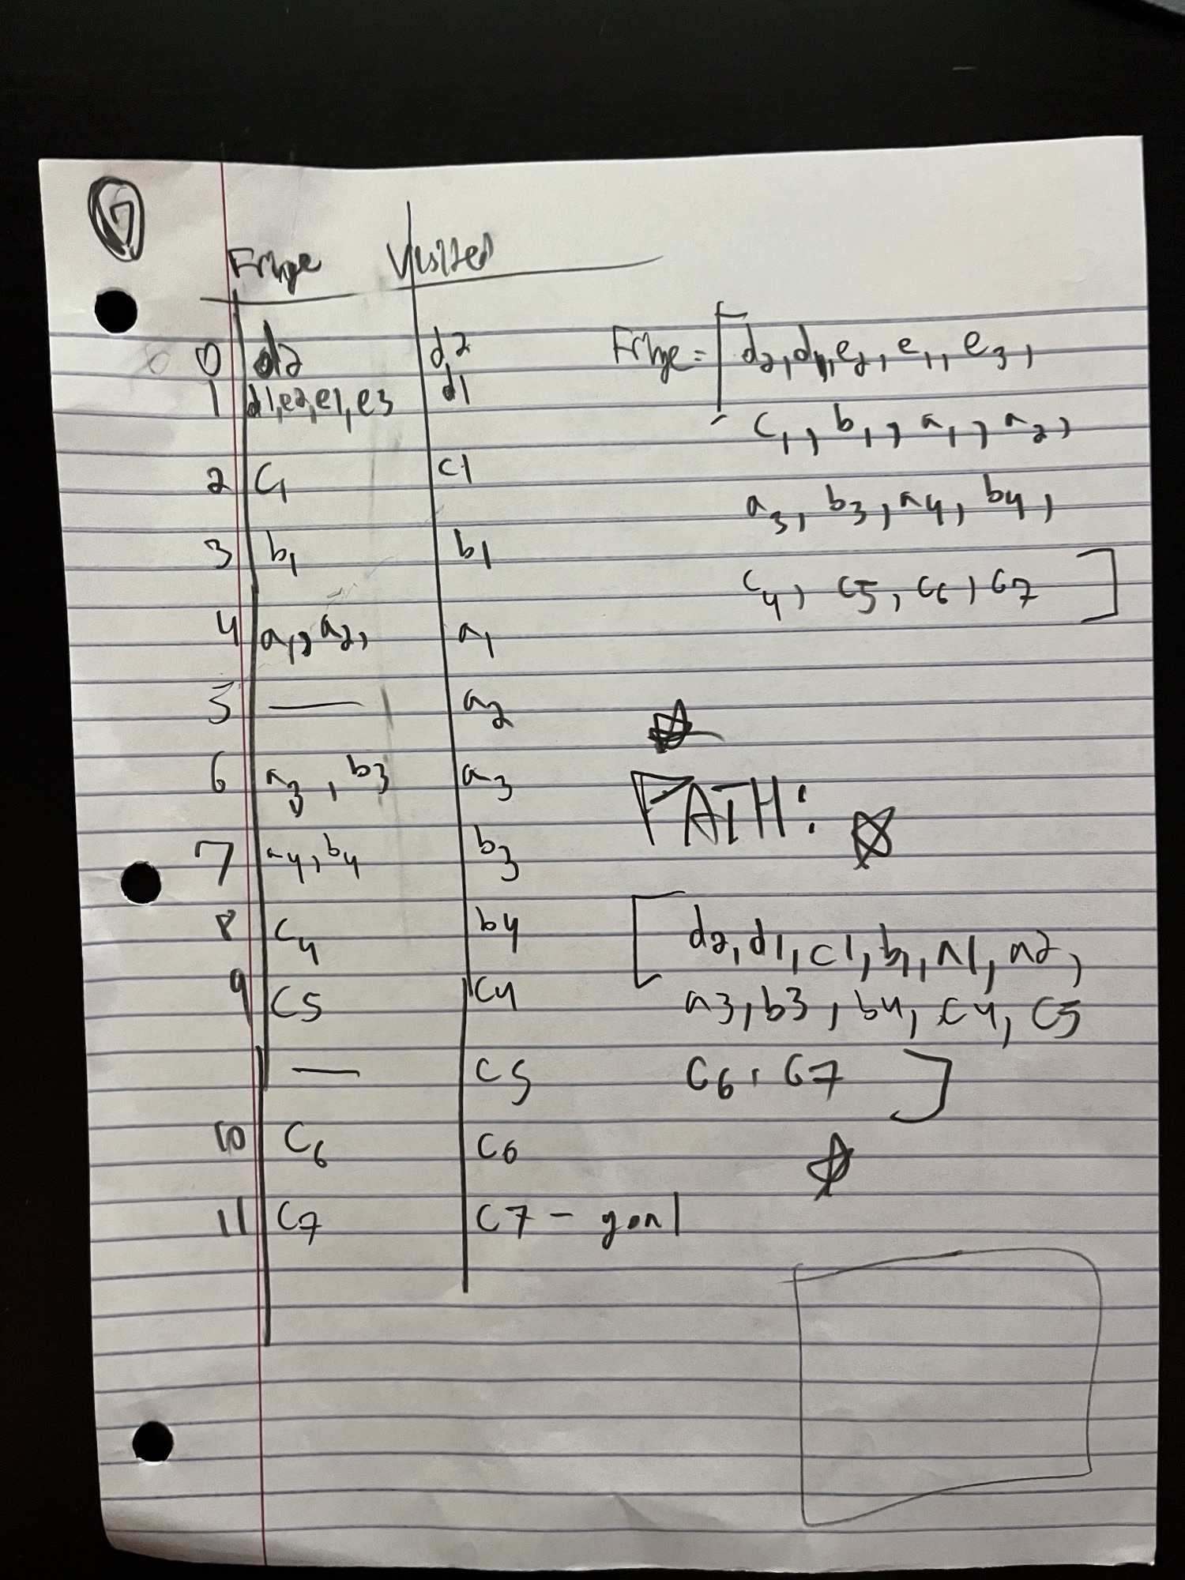

1. **[1 pt]** Figure 4 shows a robot navigation field, where the red square (d2) is the robot, and green square (c7) is the goal. The shade squares (such as b2, c2, etc.) are obstacles. The robot is not allowed to move in diagonal line. Please use A* search to find the path from d2 to c7

* Report nodes in the fringe (including their f(N) values), in the orders they are included in the fringe. [0.5]
* Report the order of the nodes being expanded. [0.25]
* Report the final path from d2 to c7. [0.25]

** See attachments **

1. [**1 pt**] Figure 5 shows a search tree where A denotes the node corresponding to the initial state, and E is the goal node. In the figure, h=x denotes the heuristic function value and c=x denotes the actual cost between nodes (i.e., arch cost).
   1. Please explain why (or why not) the heuristic function in Figure 5 is (or is not) a consistent heuristic. [0.25 pt]
   2. When carrying out A* search using the heuristic values, what are the order of the nodes being expanded? Please explain your solutions [0.25 pt]
   3. What are the possible problem of using A* search using the heuristic values in Figure 5 to search the goal node? [0.25 pt] What is solution to solve the problem? [0.25 pt]

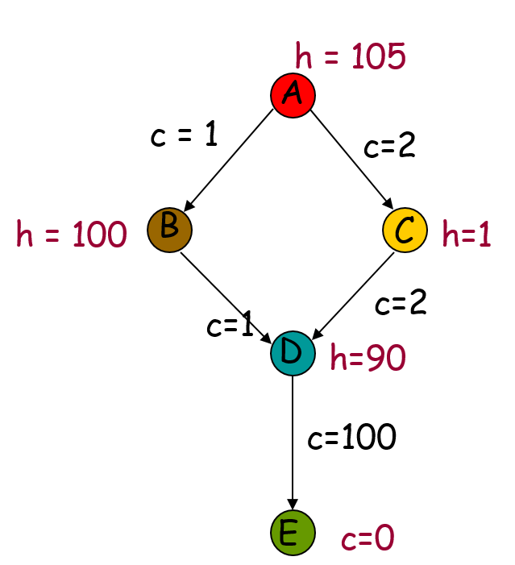

Figure 5: A search tree and husirtic function values

1. **[1 pt]** The “**InformedSearchMazeGame [Notebook, html]**” posted on Canvas shows a Maze game using A-Star Search (AStar), Greedy Best First (GBF) and Uniform Cost Search (UCS) (using “AStar”, “GBF”, or “UCS” as parameters). Use Notebook as the skeleton code, validate and compare following settings and results.
   1. Using Figure 6 as the game field, and set initial state as [0, 0] and goal state as [0, 9]. Use A-Star Search (AStar), Greedy Best First (GBF) and Uniform Cost Search (UCS) to find path from initial state to goal state, respectively. Report path of each method [0.25 pt], and explain why or why not the method is optimal [0.25 pt].

# AStar and UCS are optimal, but GBF is not because it takes more diagonals at the beginning, which cost more. See code for details

* 1. Using Figure 7 as the game field, and set initial state as [0, 0] and goal state as [0, 9]. Use A-Star Search (AStar), Greedy Best First (GBF) and Uniform Cost Search (UCS) to find path from initial state to goal state, respectively. Create a table to compare the number of expanded nodes and the maximum Fringe size of all three methods (AStar, GBF, and UCS) with respect to Figure 6 and Figure 7. Explain how the Fringe size grows with respect to the search depth for each method. [0.5 pt]

The fringe size stays relatively constant as the search depth grows, which is good. This can be reflected on the table I built in the code.

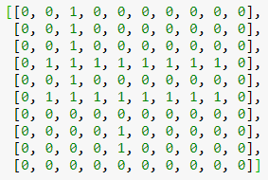 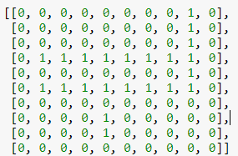

Figure 6 Figure 7

